How to set Path for JAVA_HOME and JRE_HOME in Windows
For setting path for JAVA_HOME and JRE_HOME, you need to follow these steps:
- Go to MyComputer properties -> advanced tab -> environment variables -> new tab of system variable -> write path in variable name -> write path of bin folder in variable value -> ok -> ok -> ok
1)Go to MyComputer properties
2) Click on ‘advanced System setting’ tab
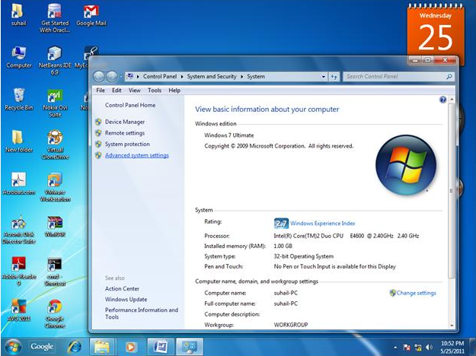

3) click on ‘environment variables’
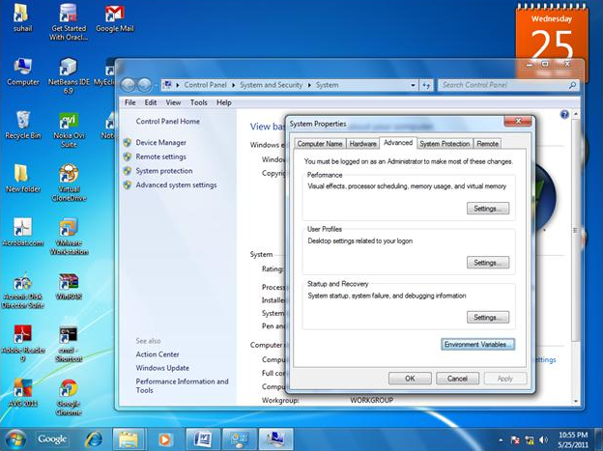

4) click on new tab of ‘system variables’
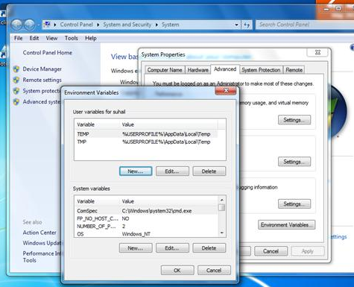
5) Write ‘JAVA_HOME’ in variable name and copy paste path of java till JDK
6) Click on new tab of ‘system variables’ and Write ‘JRE_HOME’ in variable name and copy paste path of java till JRE
7) Select ‘path’ from list of system variable and add JAVA_HOME and JRE_HOME path till bin folder as below:
% JAVA_HOME%\bin; % JRE_HOME%\bin;

Note: If ‘path’ system variable is already present in list, don’t create it use the same.
Else create ‘path’ system variable by clicking on ‘New’ button.

8) Click on ok -> ok.

