Pre-requisites

1. Please find the attached How to set path (Environment variable setting) guide. Set environment variables.
2. Login to https://t3.automationedge.com
Username: User
Password: *******

- Click on resource tab available on the left pane of AE.

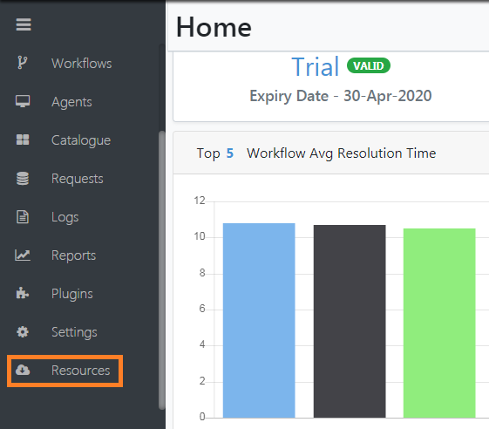

4. Download
a. Getting Started with AutomationEdge Cloud
b. Process Studio Distribution
c. Getting Started with Process Studio

5. Follow “Getting Started with AutomationEdge Cloud” to start the process studio and configure the agent.

For Quick reference:
Follow below steps to start the Process Studio:
- Login to https://t3.automationedge.com, click on “Process Studio” tab >> Click on “Assign License” button as shown in screenshot below:
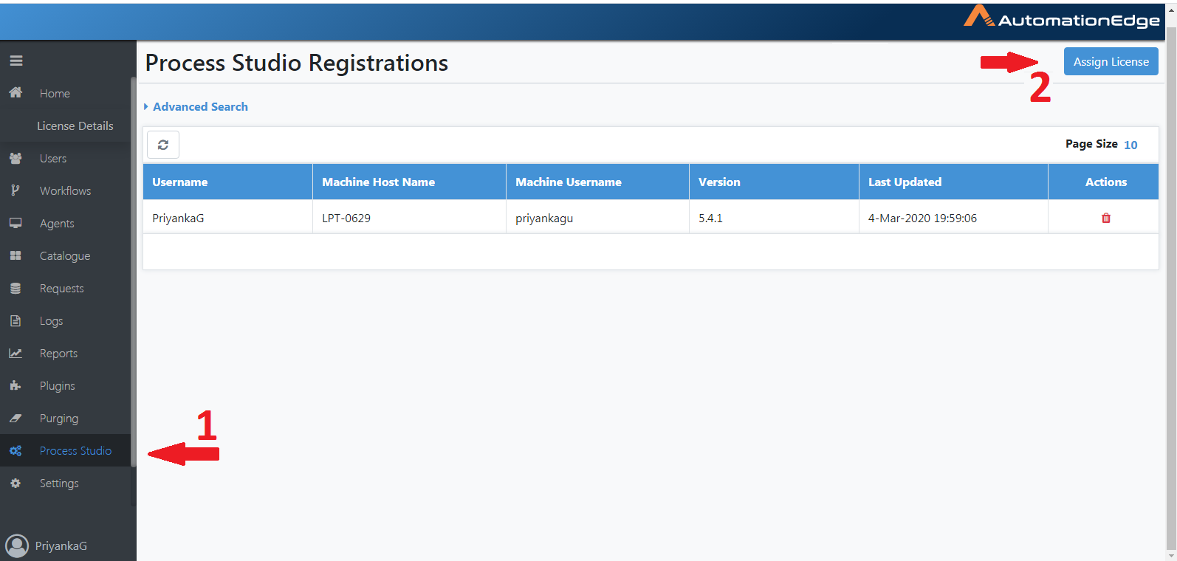

- Assign license to tenant user and save as shown in screenshot below:
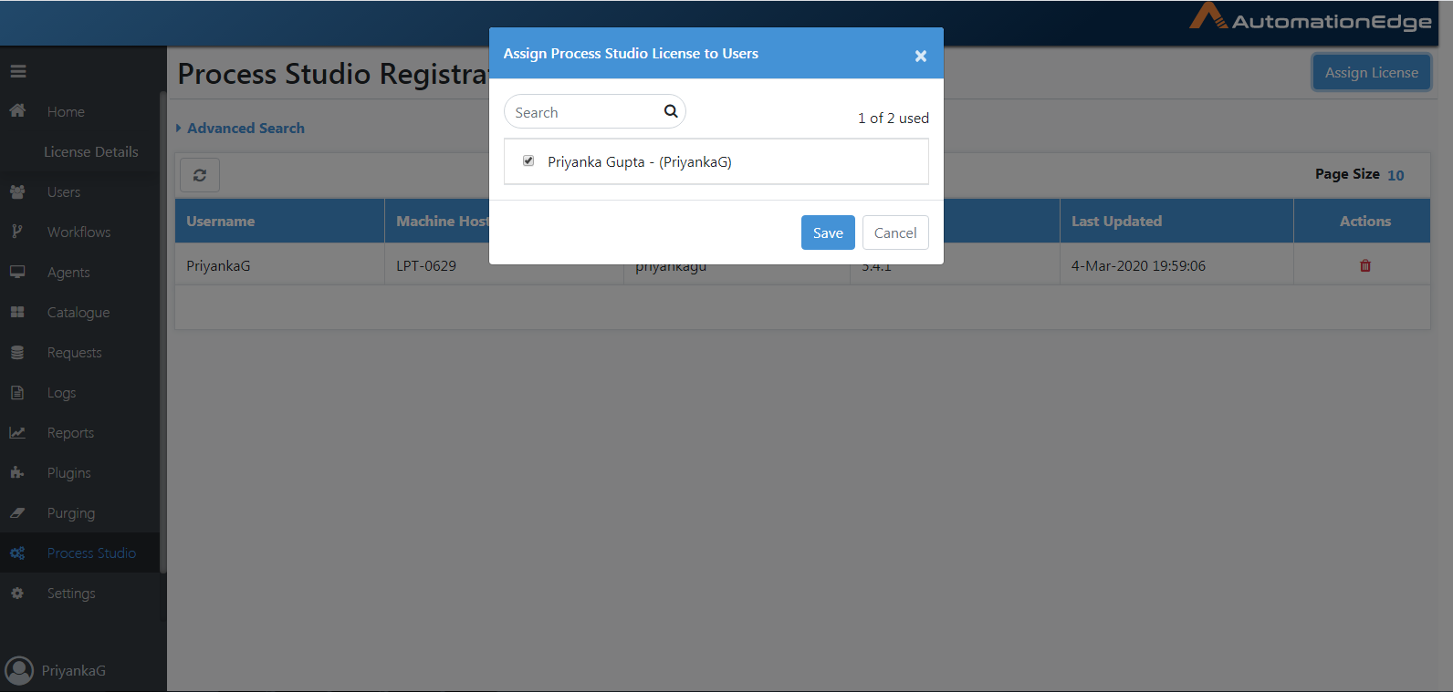

- Go to “process-studio-distribution-5.x.x” folder.
- Double-click on “Process Studio” application and enter credentials as shown in below image:
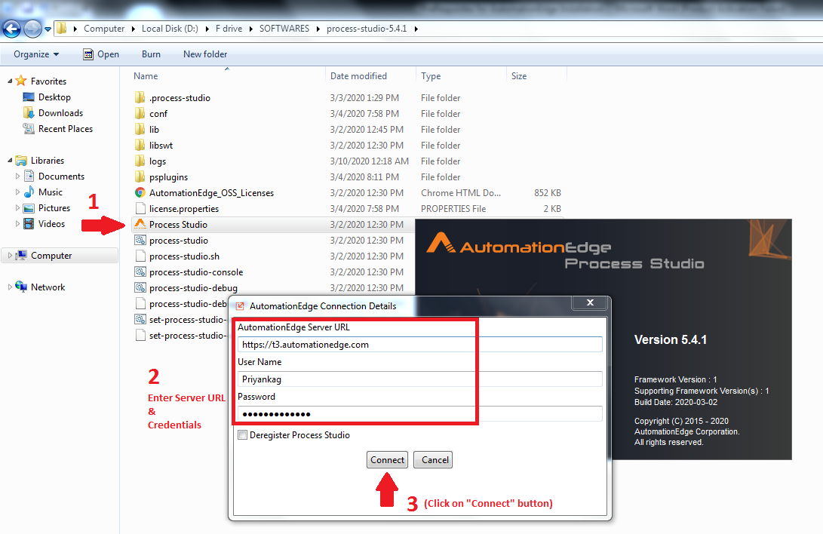

Note: Opening of Process Studio for the first time can take a while (5-7mins) because its downloads all the plugins from the server.

Troubleshooting
If Process studio is not getting started, try to start it through command prompt and check the error.

Note: To execute process studio from command prompt, follow below steps:
- Go to “process-studio-distribution-5.x.x” folder.
- Click on address bar

- Type “cmd” >> press “Enter”.
- Execute below command:
Process-studio.bat

And check the error. If error is like below image:

If it is related with memory, then edit “process-studio.bat” file.
Find for “xms” and make the following changes in “process-studio.bat” file:

- Find for “1024xms” and change it to “256xms”
- Find for “2048xmx” and change it to “512xmx”

Make same changes in “startup.bat” file also if you are receiving the same kind of error while configuring the agent.

6. For performing web application automation we will need compatible browser. Please check for browser version required for web application automation in “Getting Started with Process Studio” guide.

7. For demo purpose we will be using Gmail account for sending mail. Please lower down the security level of your Gmail accounts and also check for SMTP port enablement so that it will allow bot to send mail through that account.

Steps to lower down the Gmail security:

In case you are not able to use 'Mail' step in workflows with smtp.gmail.com SMTP server and your Gmail credentials you may do the following setting.

- Open a fresh browser where you have not logged into Google/Gmail.
- Go to https://myaccount.google.com/lesssecureapps
- Login to Google
- After putting password the screen appears. Scroll to see the following section on the screen.
- Do the setting to put on less secure apps.

Once you are done with this, your Gmail will allow access to SMTP.

8. In case proxy setting is enabled on your machine, please keep handy the proxy details with you. (These details are required for starting of Process studio and Agent)

9. For demo purpose, require a database to be installed in the machine to establish the connection between Process Studio and database (will be using Postgres).

